Changed sex to factor
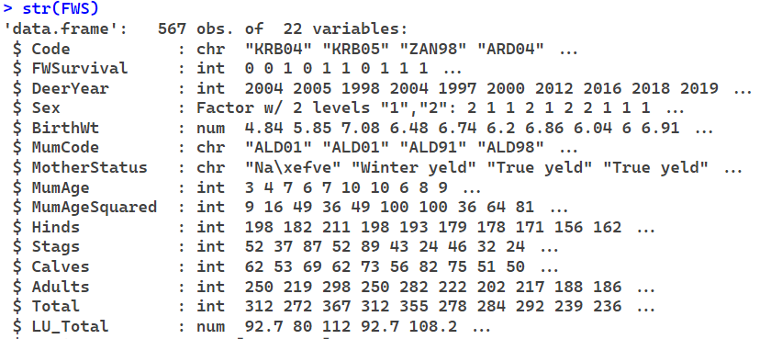

Fixed mother’s age
After fixing mother’s age, age and age squared are now both significant in all models, which would make a lot more sense. There seems to be no difference between scaled and unscaled models after this change too. I tried running glmer models again with the fixed data but it’s still encountering convergence issues so I won’t be using them for now.

The livestock unit models now give the lowest AIC values instead of Hinds. Although none of the density measures gave significant coefficients (p<0.05), the livestock unit models are the closest to being significant.
Summary
 | glmmTMB | glmmTMB  Scaled | glmmTMB  No Birthwt | glmmTMB  No Birthwt  Scaled
Hinds | -0.015 (p=0.10) | -0.32 (p=0.10) | -0.013 (p=0.15) | -0.27 (p=0.14)
Adults | 0.0082 (p=0.17) | 0.25 (p=0.17) | 0.0086 (p=0.14) | 0.26 (p=0.14)
Total | 0.0084 (p=0.11) | 0.29 (p=0.12) | 0.0088 (p=0.088) | 0.30 (p=0.090)
Livestock Units | 0.028 (p=0.065) | 0.35 (p=0.066) | 0.030 (p=0.052) | 0.36 (p=0.052)
AIC
 | glmmTMB | glmmTMB  Scaled | glmmTMB  No Birthwt | glmmTMB  No Birthwt  Scaled
Hinds | 484.3 | 484.3 | 519.1 | 519.1
Adults | 485.3 | 485.3 | 519.2 | 519.2
Total | 484.7 | 484.7 | 518.4 | 518.4
Livestock Units | 483.6 | 483.6 | 517.3 | 517.3

Hinds
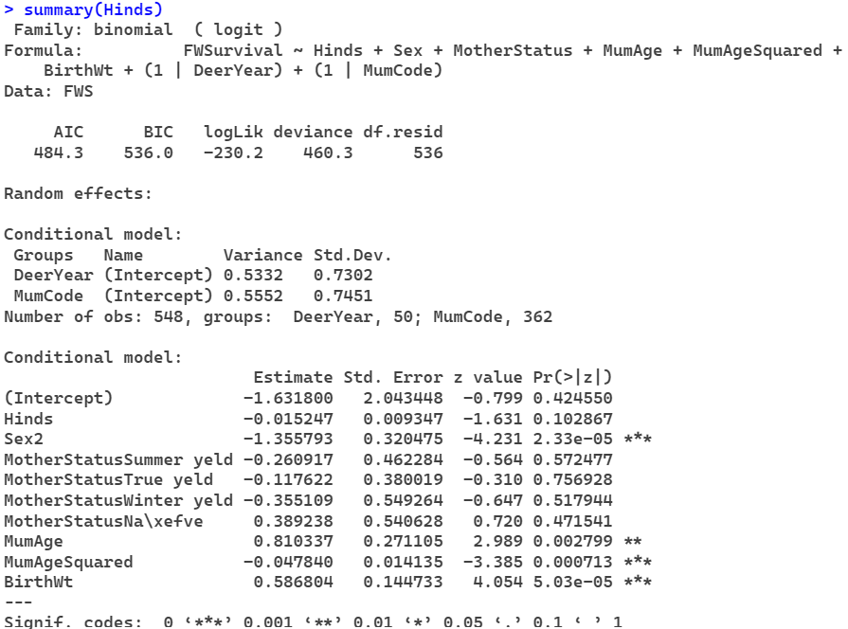

Adults
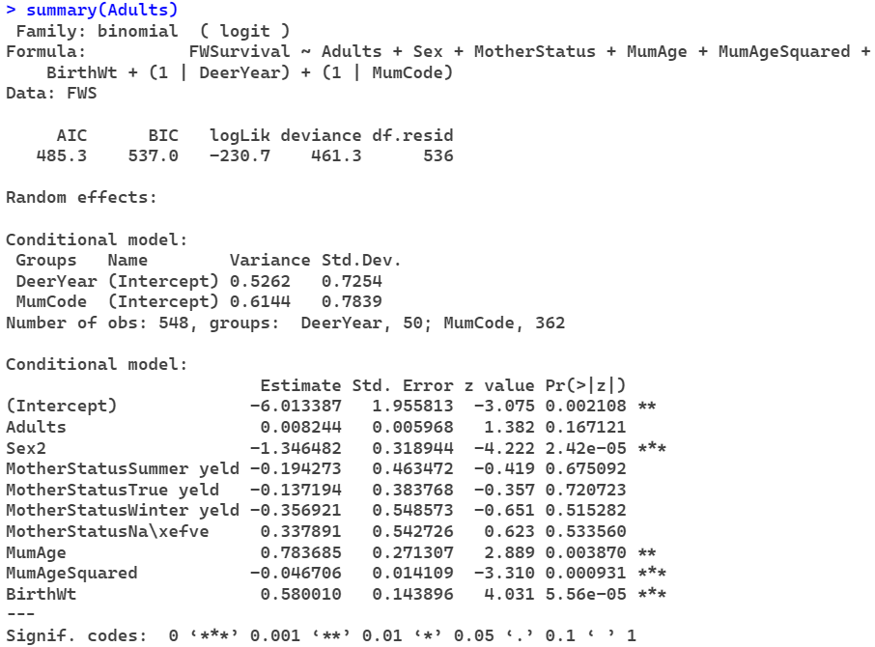
Total
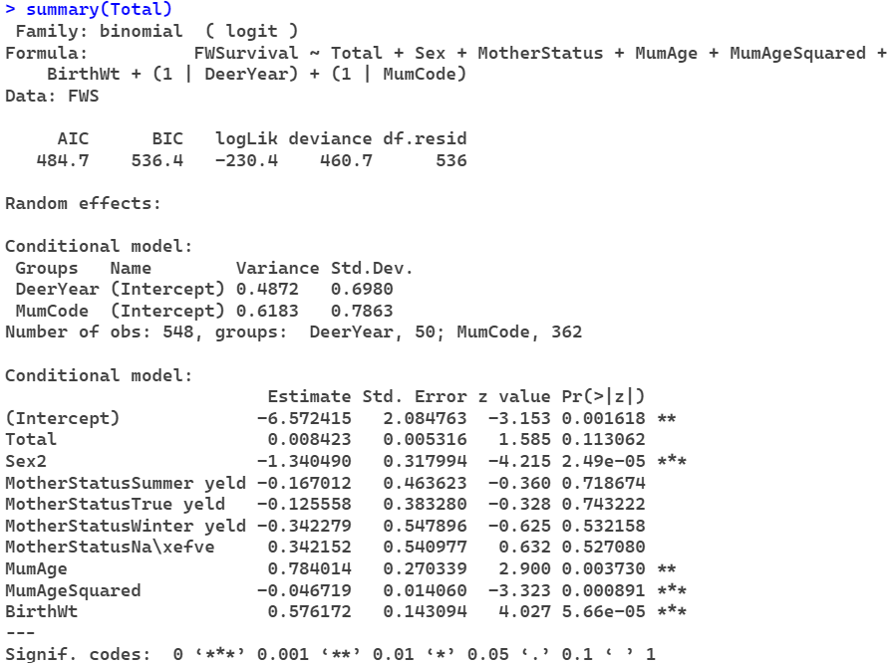

Livestock Units
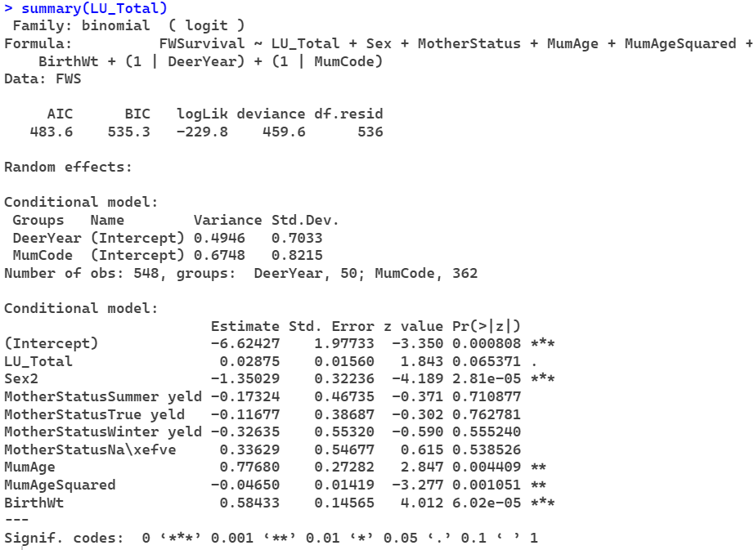
Scaled Hinds
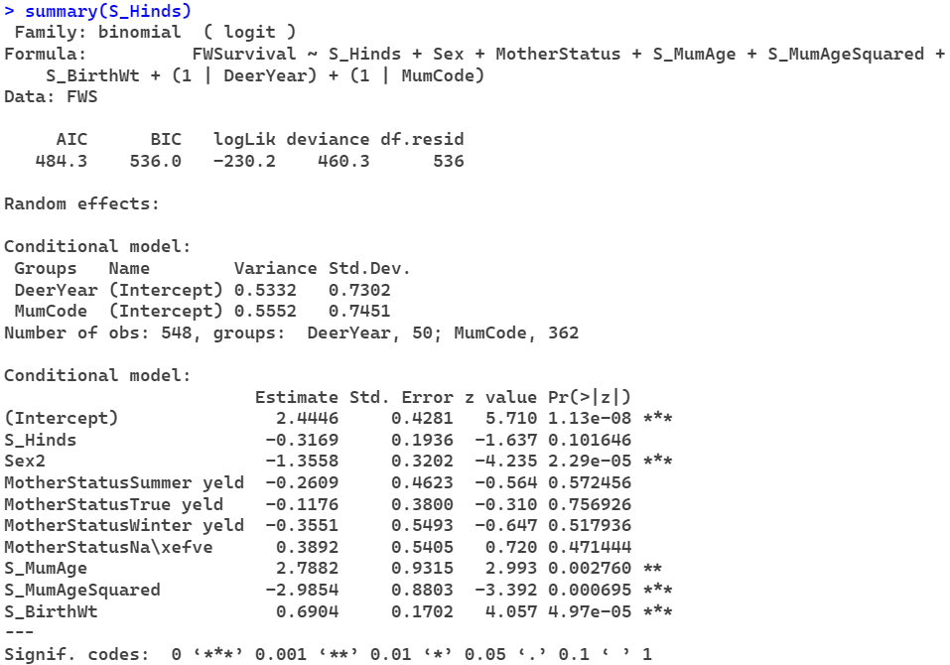
Scaled Adults
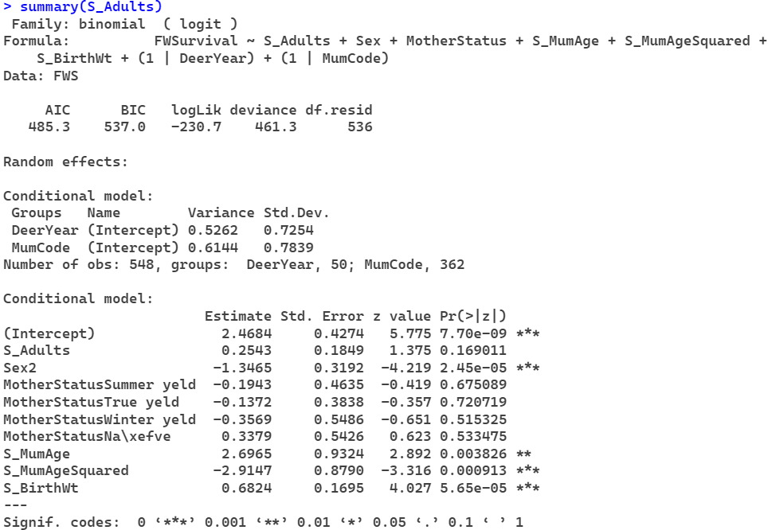

Scaled Total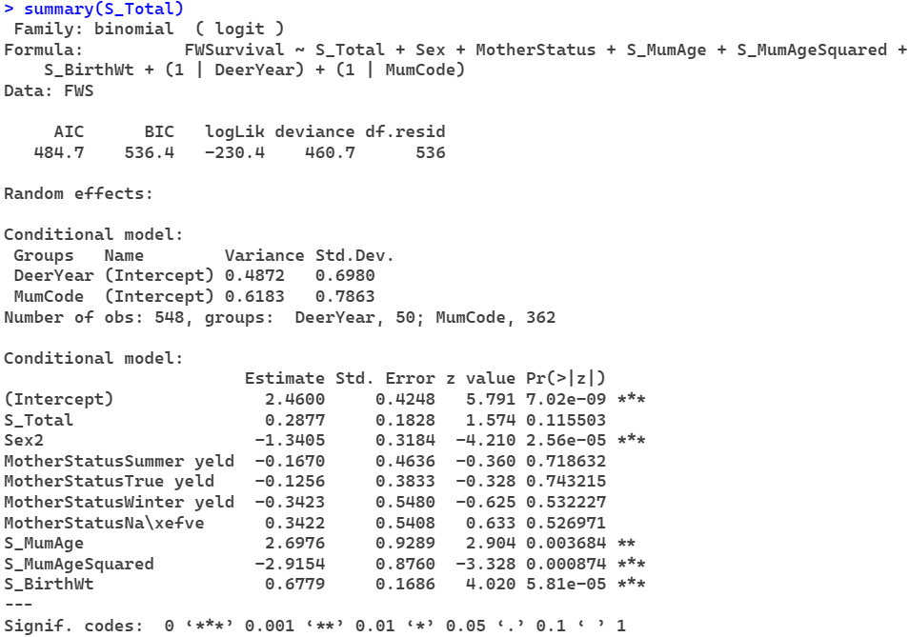
Scaled Livestock Units
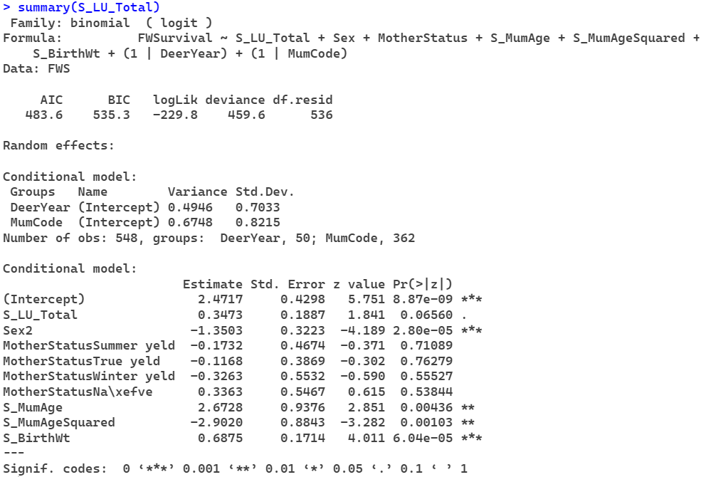

Hinds w/o birth weight
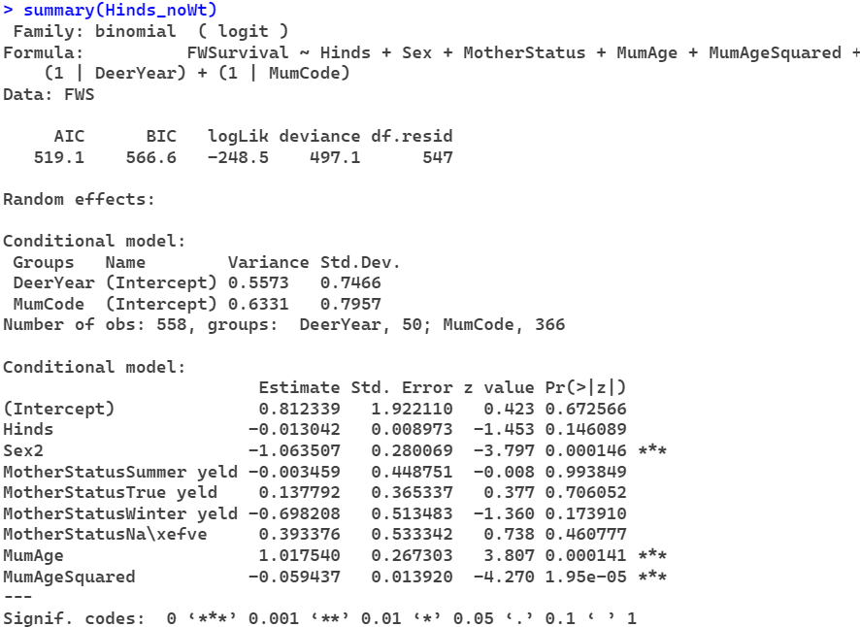
Adults w/o birth weight
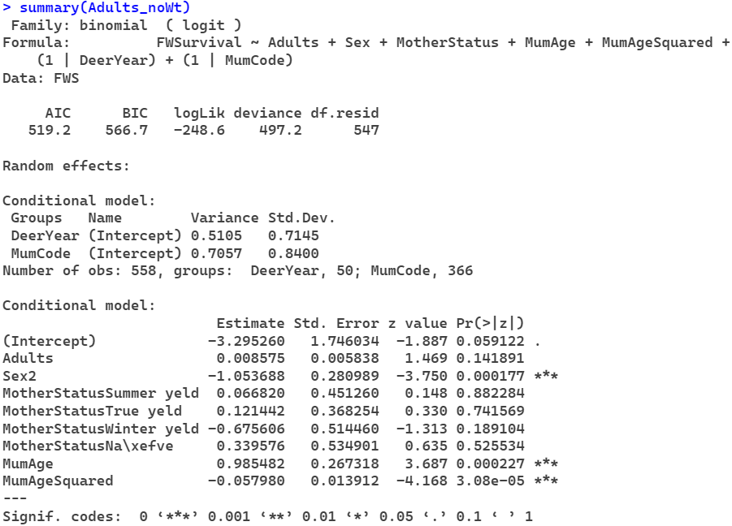
Total w/o birth weight
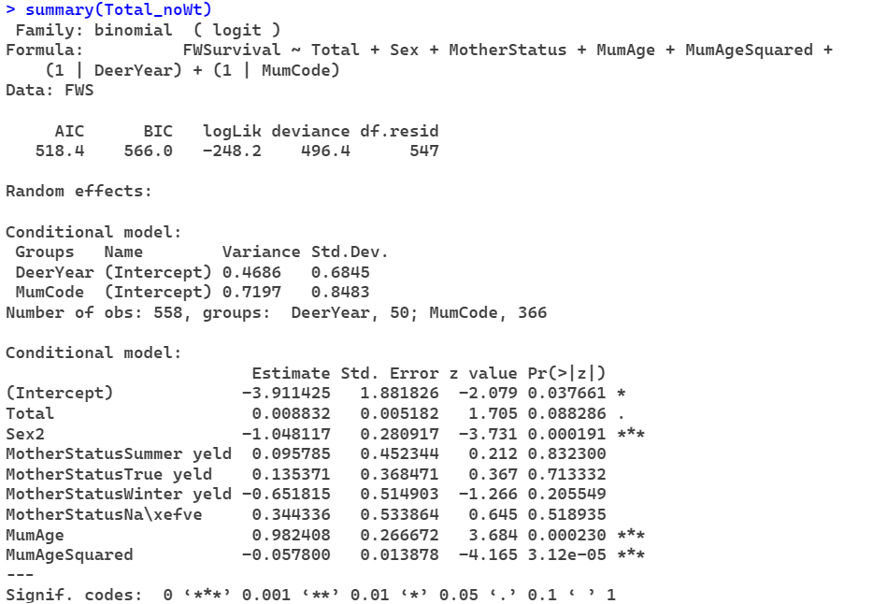

Livestock Units w/o birth weight
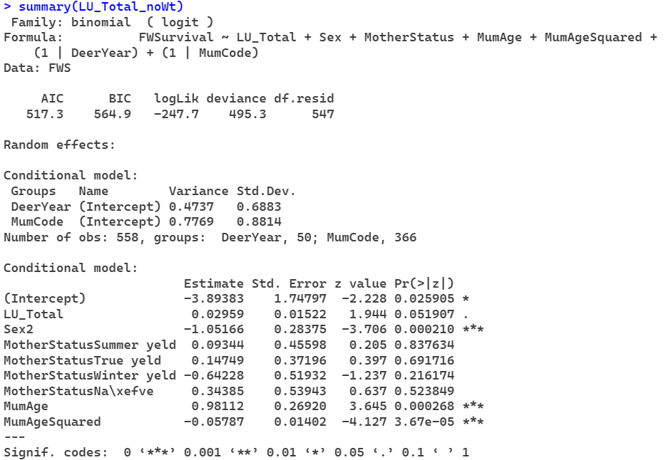
Scaled Hinds w/o birth weight
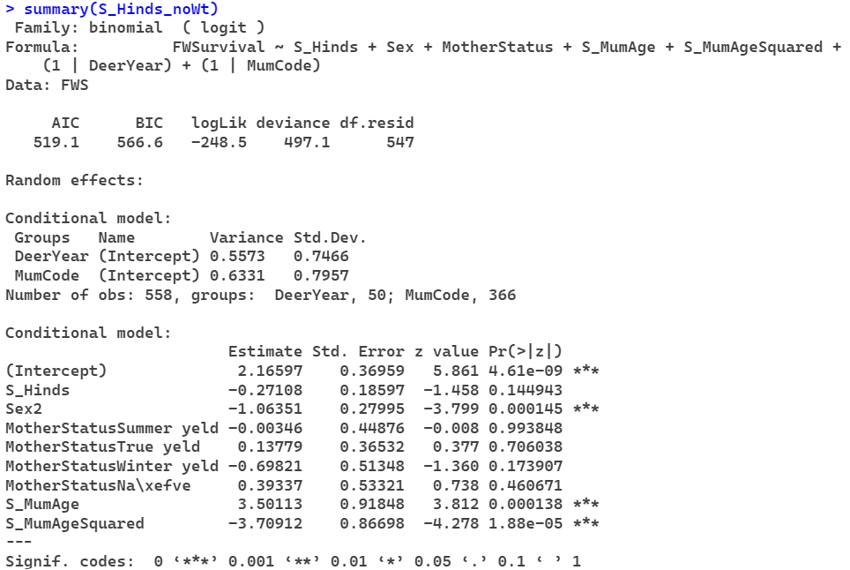
Scaled Adults w/o birth weight
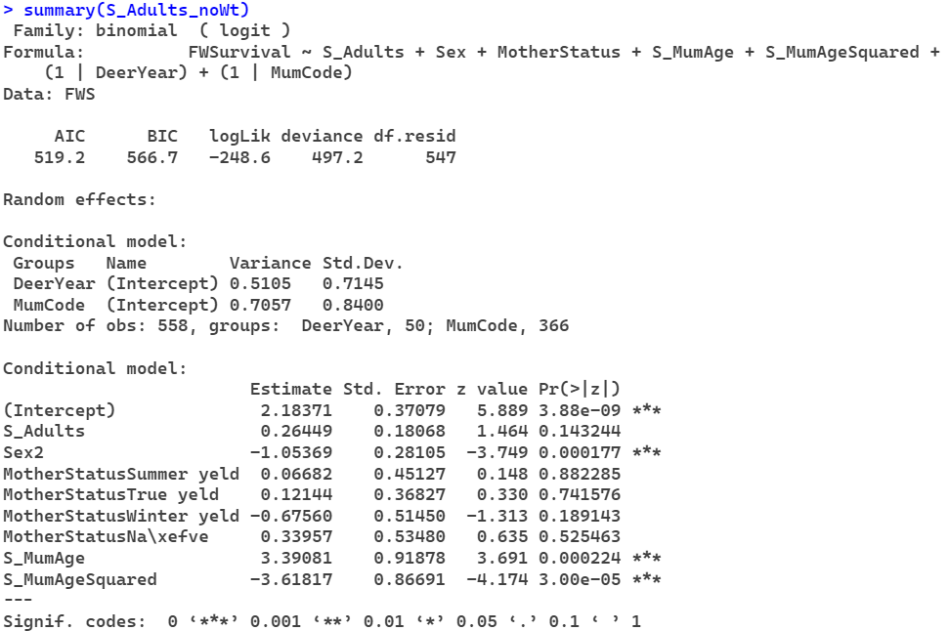

Scaled Total w/o birth weight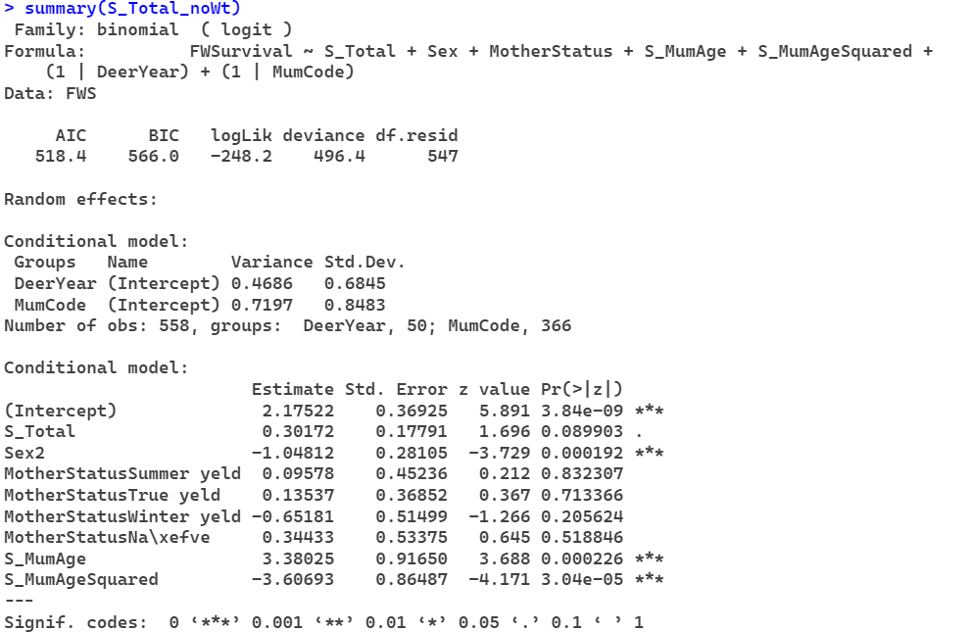
Scaled Livestock Units w/o birth weight
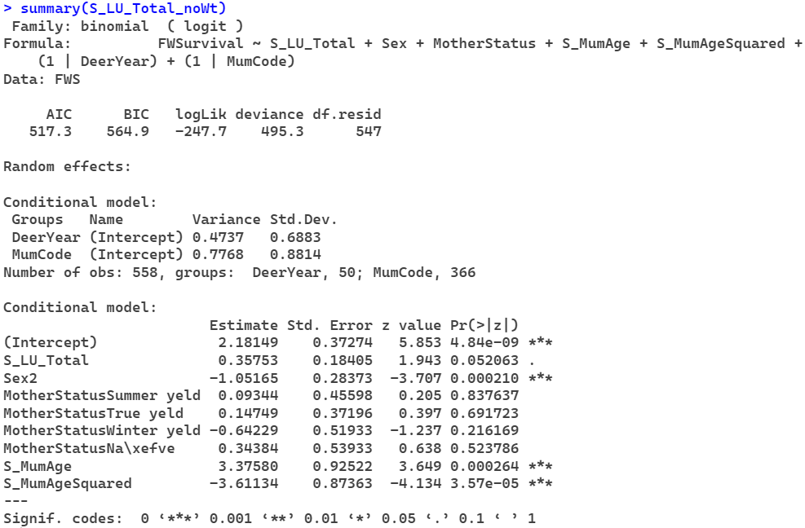

fecundity : Individual basis per year
Fit mum identity and fit mum status
External effect of mum ID

